My main buddy and Wargamer par excellence Steveie G and I got together for another game in our favorite period WWII in 20mm, “God’s” scale! It was mid week our wives were away, and the gamers will play!

We have been using CROSSFIRE rules by Artie Conliffe and we are getting to know them quite well, so well that I have been looking into converting some of the old Squad Leader scenarios into Crossfire scenarios. Squad Leader has a ton of great scenarios in them with a lot of historical research done by some real WWII scholars. Looking over the Force layout showed me that with some fairly simple force conversions, like dividing the troop strength by 1/3, leaving armor alone, and piling individual weapons into the Squads and Platoons things should work out well. Then I looked at the maps and realized that SL and ASL maps are 10 times the size we normally play Crossfire on. There was going to be no easy way to convert them…so I set to figuring out how to create my own map that would look and feel like the Squad Leader map is a size we could use for Crossfire. I read the scenario, checked victory conditions, and then studied the map trying to see what, why, and how the terrain affected the battles scenario. I then tried to reduce and combine these features while retaining the look and effect it would have on the battlefield in a size and scale that would work for our 20mm Crossfire games.

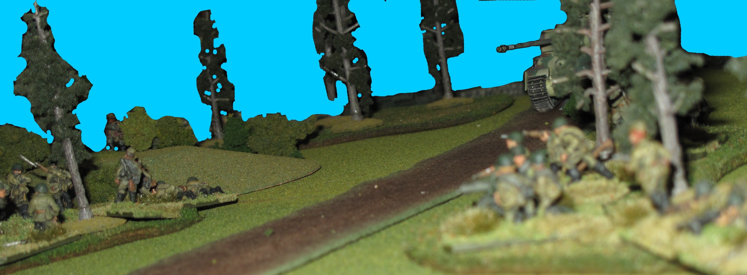

The first Scenario I decided to do was “Hube’s Pocket” a Russian front Scenario taking place in February 1944 during the trying period when the German Werhmacht was being hammered by the Soviets and only able to fight back with one hand, the other tied behind their back by “Hitler’s” no retreat orders and constant interference with his Generals.

I also picked this one because we had ALL the troops for it and Steve has beautifully painted Waffen SS that he loves to get into action. This being a relief attack by Paul Haussers 1st SS Panzer army, late war, and involved Panthers, Panzer Grenadiers, and a “target rich” environment Steve was all for it!

This would be a rescue and breakout scenario for the Germans with Russian forces simply trying to prevent this and cut off escaping German forces.

I normally do a nice map using a overhead photo of the battlefield but as we were just play testing and there were really no hidden units I didn’t as we put all troops on table as of the first move. I regretted this when writing the battle report… so you get a hand drawn one from memory…it shows both sides deployment points route taken and final position during the battle.

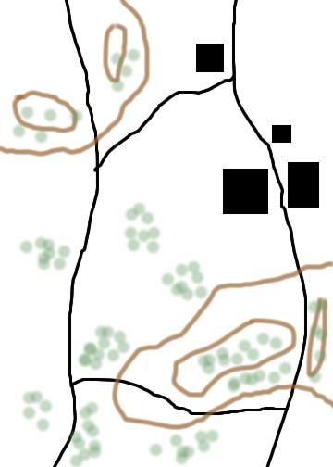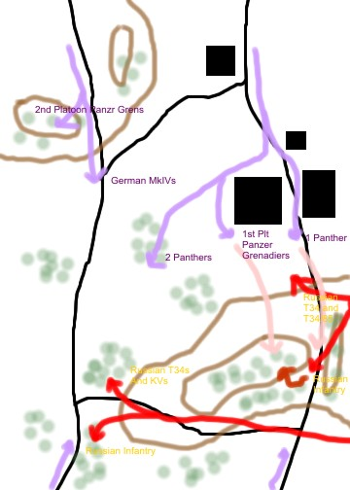

The Germans came on Strong with Panthers moving forward on the Northwest most road followed by Panzer Grenadiers in Sdkfz 251 ½ tracks just behind. The South west road saw a similar group led by a couple of PzKw IVs trying to make as much distance as they could to link up with the Germans racing West out of the “Kessel”

The cry of “Ruski Panzer” rang out as sharp eyed German commanders spotting from there unbuttoned AFVs sighted the Russians streaming out of the woods to the Northeast. Hatches slammed shut, turrets swung, armor piercing rounds slammed into breaches, “Fire”, the first rounds slammed into Russian hulls and turrets, one of the six Russians burst into flame, the others however survived the Panthers hits? The German commanders looking more closely now realized that half of the Russian armor is made up of T34/85s and KV85s! A much tougher nut to crack and one that can fight back and win, even against a Panther!

The Russians came on in a fearsome attack to destroy the Fascist Vipers before they could properly deploy. The Russian tank riders moved off and into an ambush position to the East blocking the Northern road and taking the approaching German column under fire. Russian infantry soon had the first 3 German vehicles of the column burning. The Russian Armor unfortunately had to advance across the front of the Panthers in an attempt to out flank them and get into a position to get flank shots and a fair chance of penetration against the better armored and gunned Panthers. The first Russian tank T34/76s raced forward followed by a few better gunned and armored T34/85s that took up firing positions to try and cover the T34/76s flanking moves, the 85mm guns barked and the Russian guns hit their marks, rounds bouncing off the Panthers thick hulls. The return fire from the Panthers was ineffectual, probably because of the stunning effect of the Russians fire.
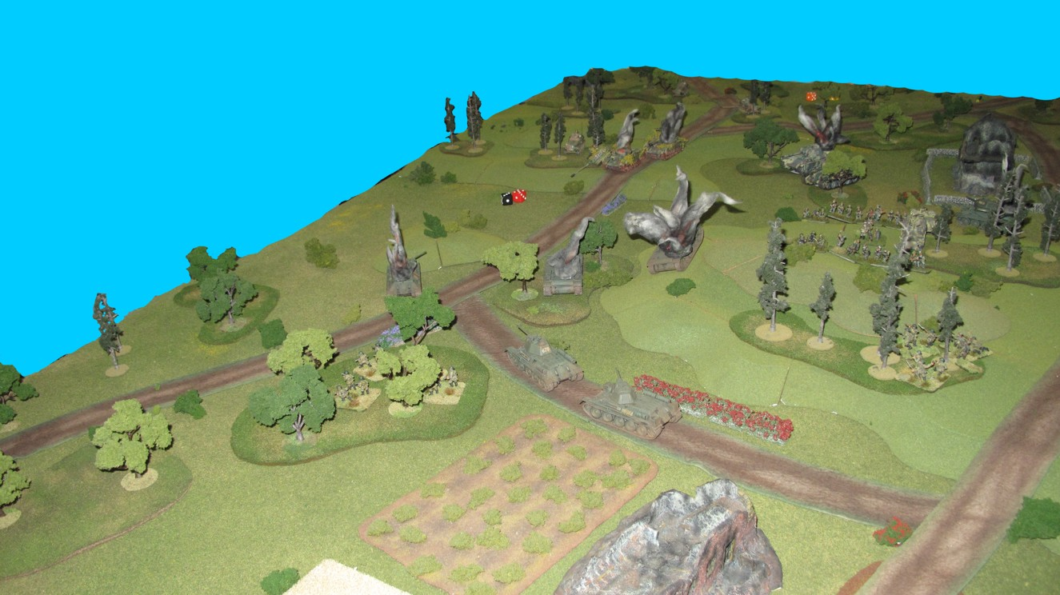

The Southern Road saw the advance of the German Mark IVHs and more Panzer Grenadiers attempting to also reach another column of 1st Panzer Armies escaping troops. The Russians had sent part of their force around the hills dominating the center of the battlefield in an attempt to take up a blocking position astride the southern road waiting for the columns of 1st Panzer Army to appear. The Russians arrived at the southern road junction and deployed around some nearby light woods just as the German MkIVs came into sight. The Russian Southern battle group was comprised of T34/76s and some very heavily armored KV85s also mounting the same powerful 85mm gun, this group was more than a match for the 2 MkIVs. As the Russian and German armor began their firefight Russian SMG armed infantry that had been riding on the tanks jumped off and took up positions in the woods along the southern road just as the 1st Panzer Armies columns came into view.

The Mark IVs fired and hit the Russians numerous times but their 75mm rounds bounced of the thick Russian armor. Russian return fire soon saw the two German Tanks burning and their accompanying Panzer Grenadiers taking cover in the woods.
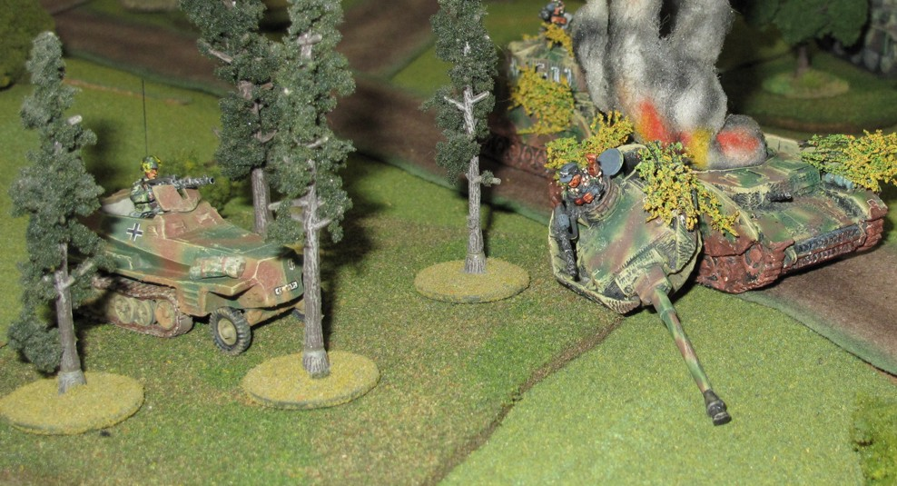
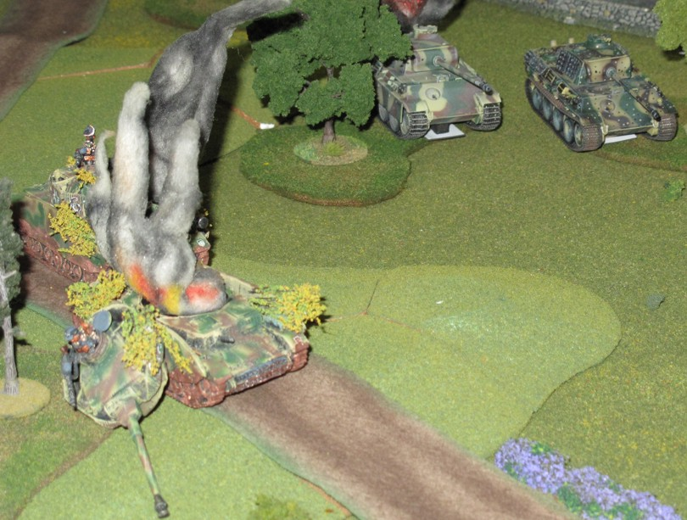

In the North the battle soon swung in favor of the Germans as the Panthers made short work of the Russian armor, 6 Russian vehicles lay destroyed and burning. The Germans now pushed forward, the way for the Panzer Grenadiers being cleared. One of the Panthers moved up to support the advance of the German infantry while the other two moved slightly south to engage the Russian armor that had just destroyed the Mark IVs. Catching the Russians off guard and to their side the Panthers soon knocked out the Russian heavies, even though the one Russian KV 85 did send a round into one of the Panthers destroying it, common sense sent the others looking for cover. The Russians had now taken devastating losses, had their armor commanders killed, and their infantry had little in the way of anti-tank weapons suited to dealing with the German heavy armor.

Panzer Grenadiers deploy in the center with support of the Northern most Panther
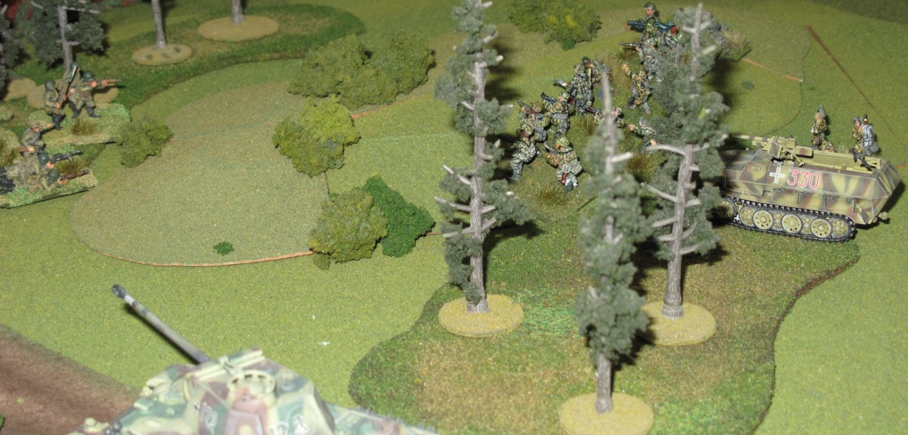

German Panthers press home their attack in the center. One Panther is “brewed up” by the KV85s potent gun. The second Panther looks for revenge!
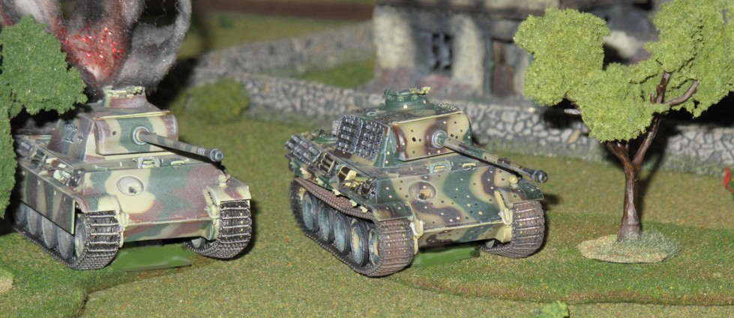

With in moments of destroying the Panther the Heavy Russian KV85 suffers the same fate at the hands of the other Panther. (yes it is a KV1 substituting for a KV85 model yet to be finished)
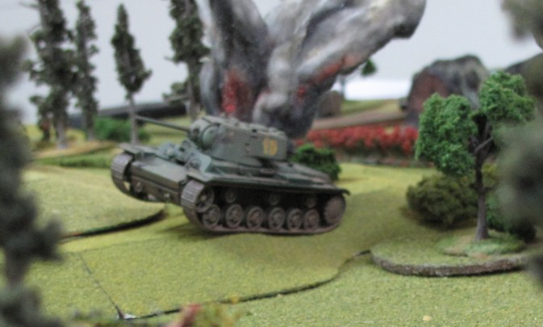

The Russians fired a few last rounds at the German infantry causing them to temporarily fall back to cover but the German panthers return fire cut deeply into the Russian infantries flank eliminating two Russian squads. The Russians infantry at this point melted back into the forest from which they came, to regroup and wait for reinforcing armor to renew the attack with!

We ended the game here and declared the try at converting a Squad Leader Scenario to Crossfire a success. Victory? Well it was not fair to say the Germans won since I don’t feel the Russians had a fair try at it. They ran out of Steam despite doing well. There should have been more Russians arriving during the battle. we will modify it slightly by for future use by giving the Russian infantry limited antitank capability, and having more Russian vehicles show up after say initiative 12 on turn generated rolls to simulate the arrival of more Russian troops as was the case. This will have the affect of causing the Germans to push harder and bring on their columns more aggressively in order to exit the ten trucks off the East board edge and victory.

The game was a lot of fun since it had clear objectives for both side and some interesting tactical deployment problems for both sides to overcome.

Steve’s Panzer Grenadiers deploy in textbook fashion preparing to assault the Russians!
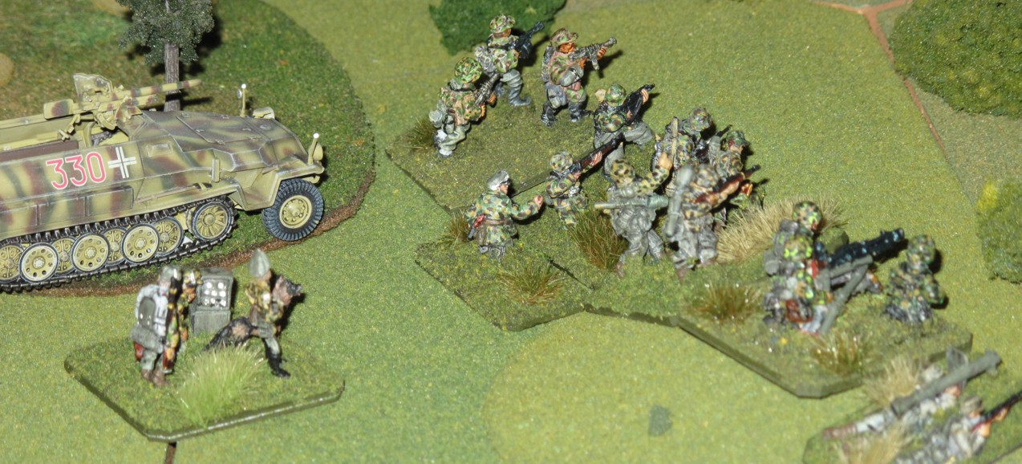

The Germans break through the Russian blocking force and rush to link up with the approaching columns.
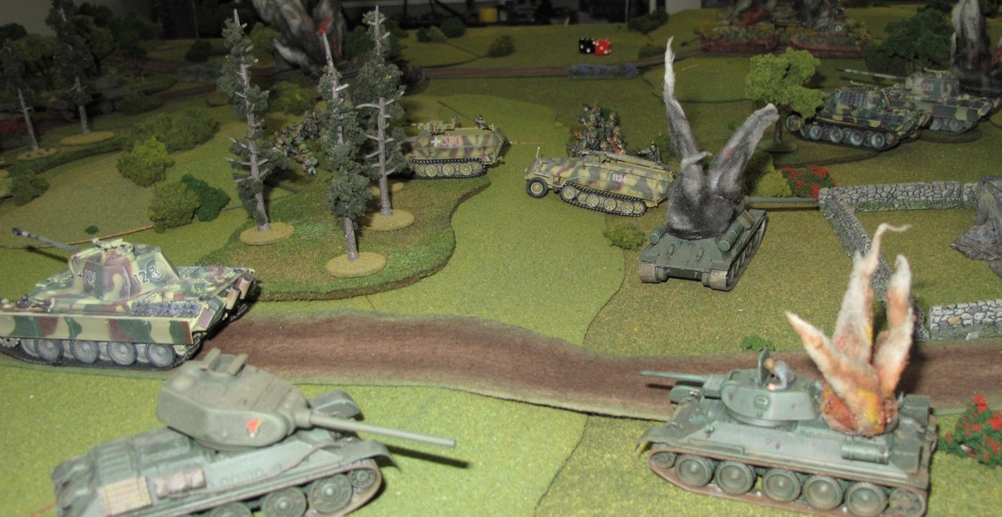

Russian infantry holding the woods is attacked in the flank by the Northern most Panther.
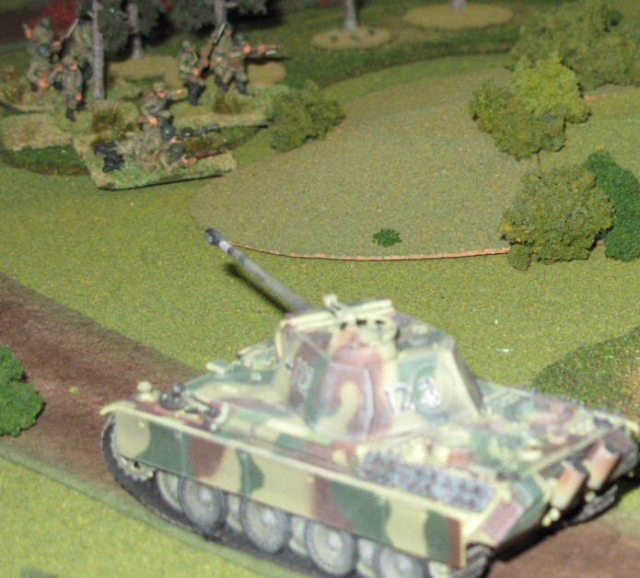

Towards the end of the battle the last Russian armor is about to turn back and lend support the remaining Russian infantry now falling back into the Southern woods.

